**Requirements:**

To run the OCT Reference Design, you’ll need a system with following

**Hardware:**

1. FPGA Card: NI PXIe-7965R **(Required)**
2. Analog Input Module **(Required)**
   1. NI 5761 (250MS/s, 4-channel, 14-bit) or
   2. NI 5762 (250MS/s, 2-channel, 16-bit)
3. Analog Output Card for Controlling Galvos **(Required)**
4. Signal Generator: NI 5450 (**Optional** for Loopback Testing)
5. Cables **(Vary with Setup)**
   1. Loopback testing
      1. 2 SMA-SMA Cables (Loop back Testing: AO of Signal Generator to Analog Input Module)
      2. 1 SMB-SMA Cable

**Software:**

1. NI LabVIEW 2011 or Later
2. NI LabVIEW FPGA 2011 or Later
3. NI-RIO 4.0 or Later
4. NI-FGEN 2.9 or Later (Loopback Testing)
5. NI GPU Analysis Toolkit (for GPU Analysis)
6. CUDA Toolkit 4.1 and appropriate display driver

**Installer**

The Reference Design has installer for only Windows platform – 32-bit. This is because NI-RIO supports only Windows 32-bit currently.

**Loopback Testing**

Connecting the OCT signals for Loopback Testing

1. **Connect Cables between Signal Generator and Digitizer Module:**

Connect the analog output of the Signal Generator (NI PXIe-5450) to FlexRIO Digitizer (NI 5761) as shown in figure below.

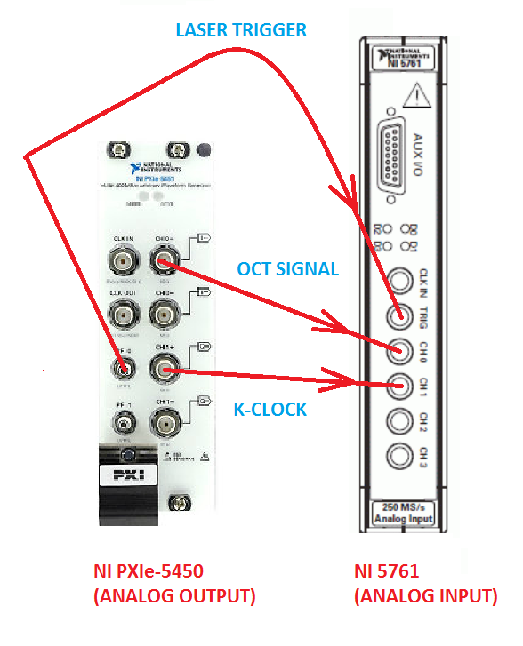

1. **Open the Project**: Open “**OCT Reference Design**” from C:\Program Files (x86)\National Instruments\LabVIEW 2011\user.lib

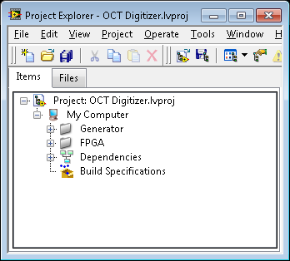

1. **Generate OCT Signals from File:** “Fgen Arb Tester (SS-OCT)_Bscan.vi” (to generate OCT Signals using Signal Generator.

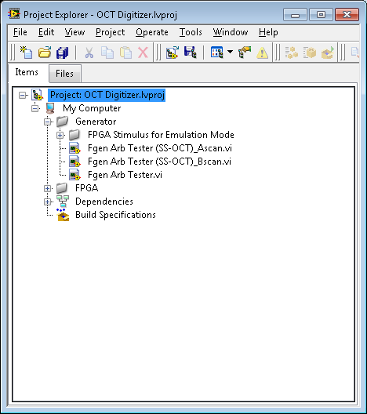 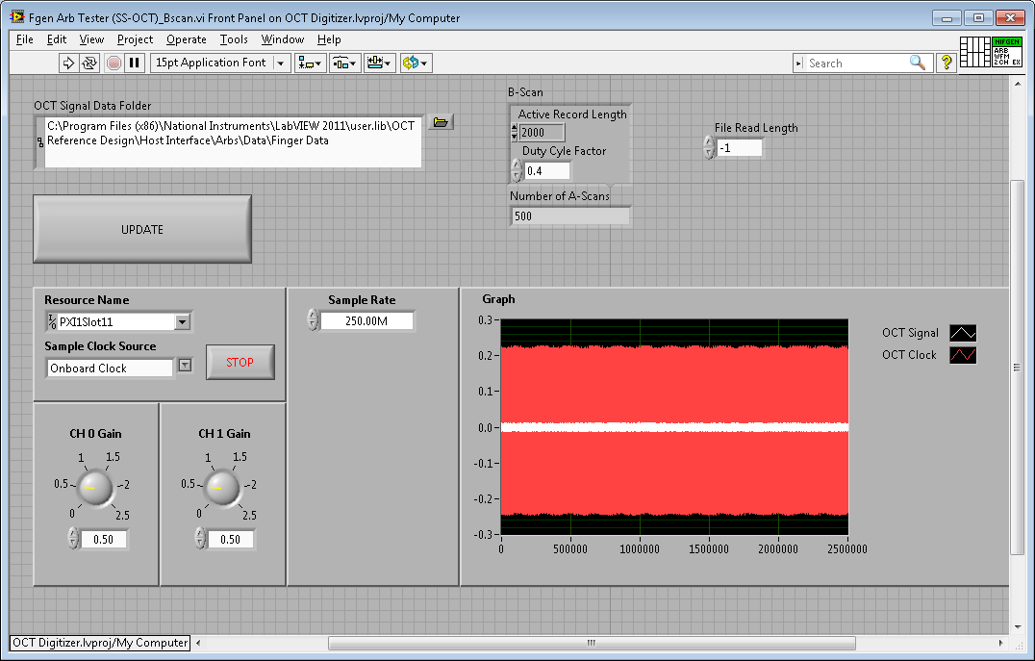

1. **Acquire OCT Signals:** Open the “Multi-Record Acquisition FFT Digitizer.vi” to start acquiring the data
   1. Click on dropdown box “Digitizer Name” and select the FlexRIO device detected by hardware
   2. Configure the Record Length: Value <2048

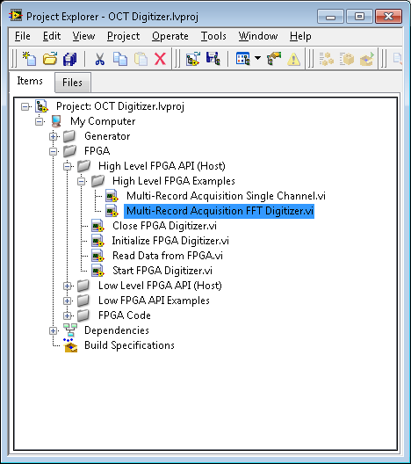 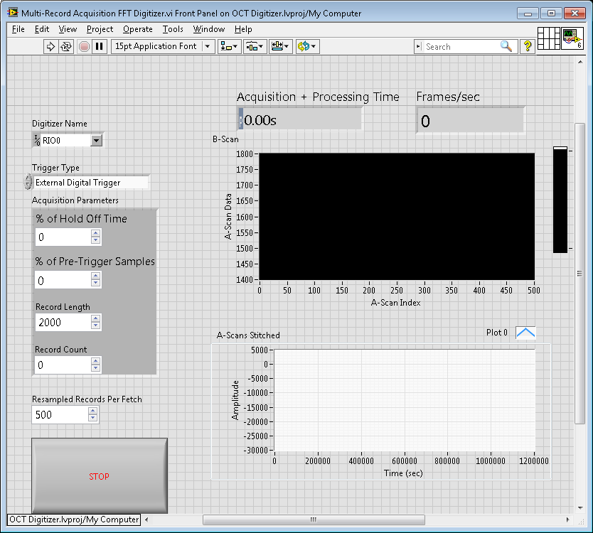

**Getting Started Video for OCT Loopback Testing**

Watch the getting started video to connect signals for Loopback Demo with Embedded Controller.

**http://www.screencast.com/users/kramu/folders/OCT%20Ref%20Design%202.0/media/52605d04-e4ad-4920-ae95-36cc995fb2c8**

**Connecting the signals to get data from live setup**

Connecting the OCT signals for Live Acquisition

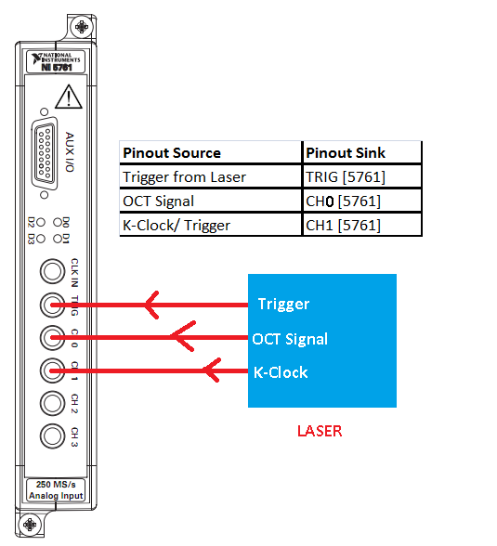

**Fig 1: OCT Connection Diagram with laser**

**Function Palettes**

The Reference Design installs VI’s under User.lib >> OCT Reference Design

**Examples**

OCT Reference Design has three examples that work out-of-the-box. You can run either to see if your installation is working:

1. Acquire Raw Data (Single Record)
2. Acquire Raw Data (Multiple Record)
3. Acquire Preprocess Stream Data

**Troubleshooting:**

1. ***Run an example***

OK, so this is probably what drove you to this section in the first place but its worth mentioning. If you haven't, give it a shot

1. ***Run the Initialize Device on the OCT Reference Design Palette***

***<screenshot of the initialize in palette>***

1. ***Online Support***

Refer to [www.ni.com/support](http://www.ni.com/support) with the error code.

­­­­